
PROJECT REPORT – INDIAN TRAFFIC SIGN CLASSIFIER

FUNDAMENTALS OF AI & ML
SLOT : B11+B12+B13
WINTER SEMESTER 2025-26

NAME – AZALFA S. ANSARI
REGISTRATION NO. –25BAI11300
INTRODUCTION
ith the rapid growth of vehicles on roads, ensuring traffic safety has become a major challenge. Traffic signs play a crucial role in guiding drivers, regulating traffic, and preventing accidents. However, recognizing and interpreting traffic signs manually can sometimes be difficult due to factors such as poor visibility, human error, and complex road conditions.
In recent years, advancements in Machine Learning and Computer Vision have enabled the development of intelligent systems that can automatically detect and classify traffic signs from images. These systems are widely used in driver assistance technologies and are an essential component of autonomous vehicles.
This project, “Indian Traffic Sign Classifier,” focuses on building a model that can identify different types of traffic signs using image data. The system is trained on a real-world dataset of Indian traffic signs and uses image processing techniques along with Machine Learning algorithms to perform classification.
The project also includes a user-friendly graphical interface, where users can upload an image of a traffic sign and receive the predicted result instantly. This demonstrates the practical application of Artificial Intelligence in solving real-world problems related to transportation and road safety.
Overall, this project provides a foundational understanding of how Machine Learning can be applied to image classification tasks and highlights its importance in modern intelligent systems

PROBLEM STATEMENT
Road safety is a major concern in India due to the increasing number of vehicles and complex traffic conditions. Traffic signs are essential for guiding drivers, enforcing rules, and preventing accidents. However, many drivers fail to notice or correctly interpret traffic signs due to factors such as poor visibility, distractions, lack of awareness, or human error.
Manual recognition of traffic signs is not always reliable, especially in fast-moving or crowded environments. This creates a need for an automated system that can accurately identify and classify traffic signs in real time.
The problem addressed in this project is to develop an automated Indian Traffic Sign Classification system using Machine Learning techniques. The system should be able to take an image of a traffic sign as input and correctly classify it into its respective category.
Additionally, the system should be user-friendly and capable of providing quick predictions through a graphical interface. The goal is to assist drivers and contribute towards improving road safety by reducing human dependency in traffic sign recognition.
This project aims to bridge the gap between traditional traffic systems and intelligent automated solutions by applying concepts of Computer Vision and Machine Learning.

FUNCTIONAL REQUIREMENTS

The functional requirements describe the main features and operations that the Indian Traffic Sign Classifier system must perform.
- Image Input
  - The system should allow the user to upload an image of a traffic sign from the local system.
- Image Preprocessing
  - The system should resize the input image to a fixed size (e.g., 32×32 pixels).
  - The system should convert the image into grayscale and normalize pixel values for better processing.
- Model Loading
  - The system should load the pre-trained Machine Learning model (model.pkl) and label mapping (labels.pkl) at runtime.
- Prediction
  - The system should process the input image and classify it into one of the predefined traffic sign categories.
  - The system should generate a prediction based on the trained model.
- Display Output
  - The system should display the predicted traffic sign name (not just numeric label) to the user.
- Graphical User Interface (GUI)
  - The system should provide a simple and user-friendly interface using Tkinter.
  - The GUI should include buttons for image upload and a section to display results.
- Error Handling
  - The system should handle invalid or unsupported image files.
  - The system should display appropriate error messages if the image cannot be processed.
- Model Training (Offline Functionality)
  - The system should allow training of the model using a dataset of traffic sign images.
  - The trained model should be saved for future use.

NON-FUNCTIONAL REQUIREMENTS
Non-functional requirements define the quality, performance, and usability aspects of the Indian Traffic Sign Classifier system.
- Performance
  - The system should provide predictions within a few seconds after image upload.
  - It should efficiently handle multiple images without significant delay.
- Accuracy
  - The system should provide reasonably accurate predictions based on the trained model.
  - Accuracy may vary depending on image quality and dataset limitations.
- Usability
  - The system should have a simple and user-friendly interface.
  - Users should be able to operate the application without technical knowledge.
- Reliability
  - The system should work consistently without crashing or producing unexpected errors.
  - It should handle invalid inputs gracefully.
- Scalability
  - The system should allow future improvements such as adding more traffic sign classes or upgrading the model (e.g., using deep learning).
- Maintainability
  - The code should be well-structured and easy to update or modify.
  - New features or improvements should be easily integrated.
- Portability
  - The system should run on different systems with minimal setup (Windows, Linux, etc.) provided required libraries are installed.
- Security
  - The system should safely handle user-uploaded images without storing or misusing data.
  - No sensitive user data should be exposed.
- Resource Efficiency
  - The system should use moderate CPU and memory resources.
  - It should be able to run on standard computers without requiring high-end hardware.

SYSTEM ARCHITECTURE
The system architecture of the Indian Traffic Sign Classifier describes how different components of the system interact to perform traffic sign recognition. The system is divided into two main parts: Model Training Module and Prediction Module (GUI Application).

🔹 1. Model Training Module
This module is responsible for building the Machine Learning model.
- Input: Traffic sign image dataset
- Process:
  - Load dataset from directory
  - Preprocess images (resize, grayscale conversion, normalization)
  - Convert images into numerical format
  - Train Machine Learning model (KNN / Random Forest)
- Output:
  - Trained model (model.pkl)
  - Label mapping file (labels.pkl)

🔹 2. Prediction Module (GUI Application)
This module allows the user to interact with the system.
- Input: User-uploaded traffic sign image
- Process:
  - Load trained model and labels
  - Preprocess input image (same steps as training)
  - Predict traffic sign class
  - Map predicted class to actual sign name
- Output:
  - Display predicted traffic sign on screen

🔄 System Flow
- User uploads an image through GUI
- Image is preprocessed
- Model analyzes the image
- Prediction is generated
- Result is displayed to the user

🧩 Components of the System
- Dataset (Traffic Sign Images)
- Image Processing Module (OpenCV)
- Machine Learning Model (Scikit-learn)
- GUI Interface (Tkinter)
- Model Storage (Pickle files)

📊 Architecture Diagram (Textual Representation)
[Dataset]
↓
[Preprocessing]
↓
[Model Training]
↓
[Model Saved (model.pkl, labels.pkl)]

-------------------------------

[User Input Image]
↓
[Preprocessing]
↓
[Trained Model]
↓
[Prediction]
↓
[GUI Display Output]

DESIGN DIAGRAMS
Design diagrams help in understanding the working and structure of the Indian Traffic Sign Classifier system. The following diagrams represent the flow and interaction of different components.

🔹 1. Data Flow Diagram (DFD)
The Data Flow Diagram shows how data moves through the system.
User → Upload Image → Preprocessing → Model → Prediction → Display Result
Explanation:
- The user uploads an image through the GUI.
- The image is preprocessed (resize, grayscale, normalization).
- The trained model processes the image.
- The system predicts the traffic sign.
- The result is displayed to the user.

🔹 2. Flowchart
The flowchart represents the step-by-step working of the system.
Start
↓
Load Model & Labels
↓
User Uploads Image
↓
Is Image Valid?
↓ ↓
Yes No
↓ ↓
Preprocess Show Error
↓
Predict Class
↓
Display Result
↓
End

🔹 3. System Block Diagram
This diagram shows the main components of the system.
[Dataset] → [Preprocessing] → [Model Training] → [Saved Model]

[User] → [GUI] → [Preprocessing] → [Model] → [Output Display]

🔹 4. Use Case Diagram (Text Representation)
Actor: User

Use Cases:
- Upload Image
- View Prediction
- Receive Error Message (if invalid input)

🔹 5. Component Diagram
[GUI (Tkinter)]
↓
[Image Processing (OpenCV)]
↓
[ML Model (Scikit-learn)]
↓
[Output Display]

DESIGN DECISIONS & RATIONALE
This section explains the key design choices made during the development of the Indian Traffic Sign Classifier and the reasons behind selecting them.

🔹 1. Choice of Machine Learning Algorithm
- Decision: Used K-Nearest Neighbors (KNN) / Random Forest algorithm
- Rationale:
  - Simple and easy to implement
  - Works well for small to medium-sized datasets
  - Does not require complex setup like deep learning frameworks
  - Suitable for academic and demonstration purposes

🔹 2. Image Preprocessing
- Decision: Resize images to 32×32 pixels, convert to grayscale, and normalize values
- Rationale:
  - Reduces computational cost
  - Ensures uniform input size
  - Grayscale simplifies data while retaining important features
  - Normalization improves model performance

🔹 3. Feature Representation
- Decision: Flatten images into 1D arrays
- Rationale:
  - Required for traditional Machine Learning models
  - Simple and efficient approach
  - Avoids complexity of feature extraction techniques

🔹 4. Use of Real Dataset
- Decision: Used Kaggle Indian Traffic Sign Dataset
- Rationale:
  - Provides real-world data
  - Improves practical understanding
  - Makes project more realistic and professional

🔹 5. Model Storage
- Decision: Save model using Pickle (model.pkl, labels.pkl)
- Rationale:
  - Allows reuse without retraining
  - Saves time and computational resources
  - Easy to load and deploy

🔹 6. GUI Development
- Decision: Used Tkinter for GUI
- Rationale:
  - Built-in Python library (no extra installation required)
  - Simple and lightweight
  - Suitable for beginner-friendly interface

🔹 7. Modular Design
- Decision: Separate training and prediction modules
- Rationale:
  - Improves code organization
  - Makes system easy to maintain and update
  - Allows independent development of components

🔹 8. Handling Large Model File
- Decision: Excluded model file from GitHub repository
- Rationale:
  - GitHub size limitations (25 MB)
  - Model can be regenerated using training script
  - Keeps repository lightweight

IMPLEMENTATION DETAILS

import os
import cv2
import numpy as np
import pickle
from sklearn.ensemble import RandomForestClassifier

IMG_SIZE = 32

images = []
labels = []

label_map = {}
current_label = 0

print("Loading dataset...")

data_path = r"C:\Users\AZALFA\.cache\kagglehub\datasets\neelpratiksha\indian-traffic-sign-dataset\versions\1\Indian-Traffic Sign-Dataset\Images"

# Load images
for label in os.listdir(data_path):
class_folder = os.path.join(data_path, label)

if os.path.isdir(class_folder):
if label not in label_map:
label_map[label] = current_label
current_label += 1

for file in os.listdir(class_folder):
img_path = os.path.join(class_folder, file)

img = cv2.imread(img_path)
img = cv2.cvtColor(img, cv2.COLOR_BGR2GRAY)
if img is None:
continue

img = cv2.resize(img, (IMG_SIZE, IMG_SIZE))
img = img / 255.0 # ✅ normalize
images.append(img.flatten())
labels.append(label_map[label])

print("Total images:", len(images))

# Convert to numpy
X = np.array(images)
y = np.array(labels)

# Train model ✅
print("Training model...")
model = RandomForestClassifier(n_estimators=100)
model.fit(X, y)

# Save model ✅ AFTER training
with open("model.pkl", "wb") as f:
pickle.dump(model, f)

with open("labels.pkl", "wb") as f:
pickle.dump(label_map, f)

print("✅ Model saved successfully!")
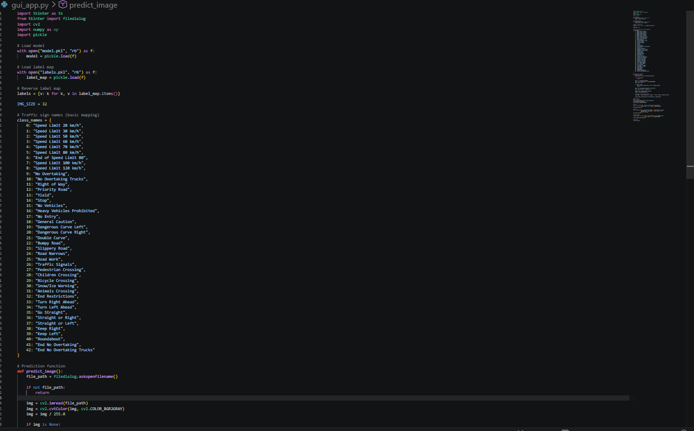
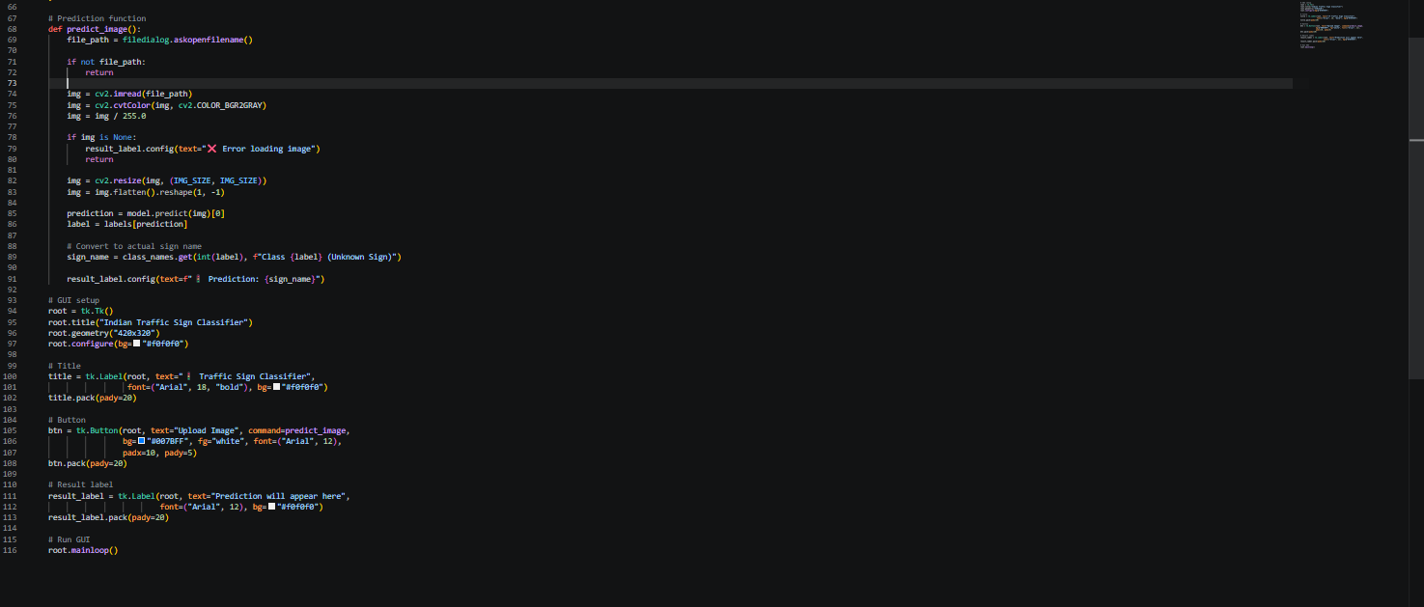

SCREENSHOTS / RESULTS
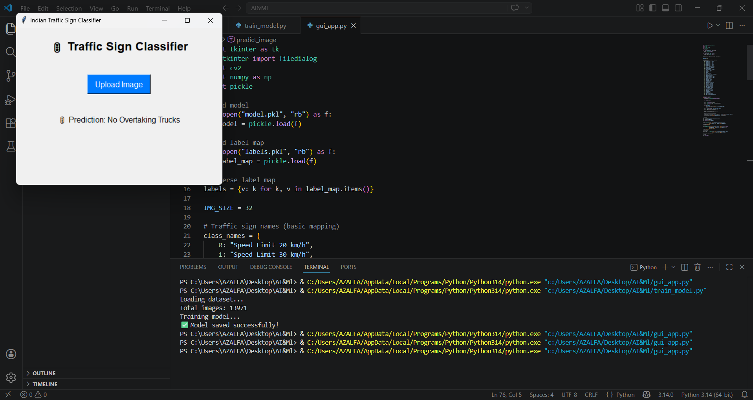
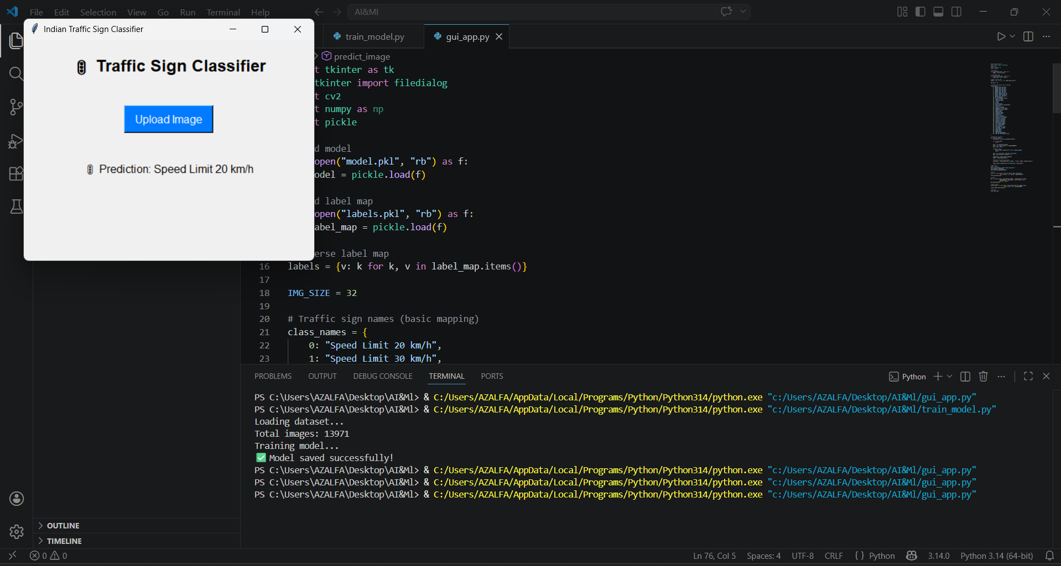
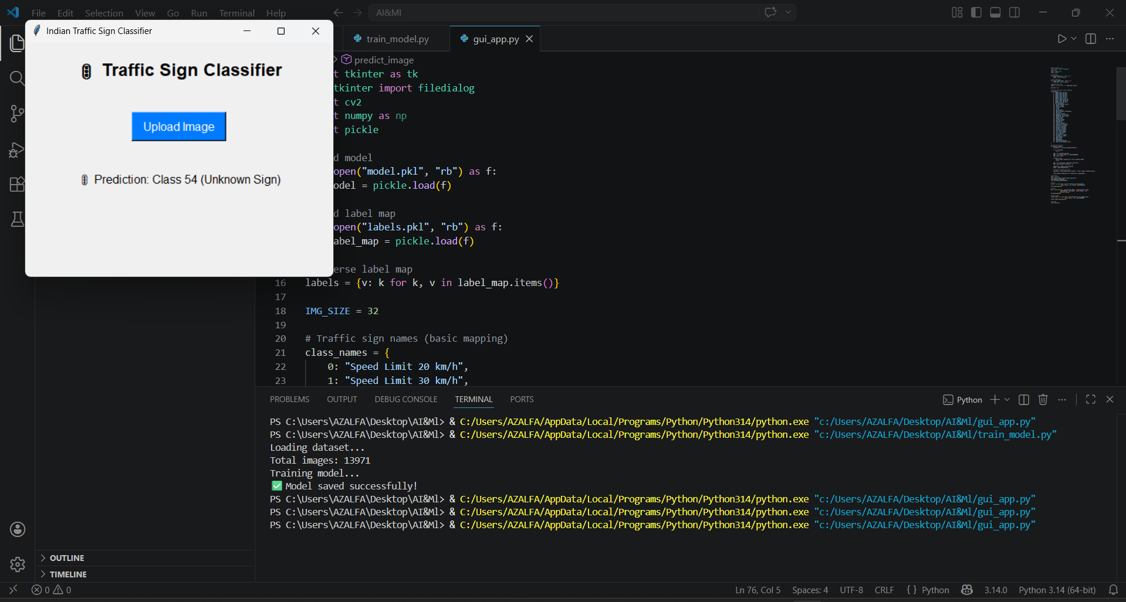

TESTING APPROACH
The testing approach defines how the Indian Traffic Sign Classifier system was tested to ensure correct functionality, accuracy, and reliability.

🔹 1. Unit Testing
- Individual components of the system were tested separately.
- Dataset loading, image preprocessing, and model prediction functions were verified independently.
- Ensured that each module works correctly before integration.

🔹 2. Integration Testing
- Combined all modules (dataset processing, model, and GUI) and tested them together.
- Verified that the system correctly processes input images and displays predictions.

🔹 3. Functional Testing
- Tested all functionalities of the system:
  - Upload image feature
  - Image preprocessing
  - Prediction generation
  - Display of output
- Ensured that the system behaves as expected for valid inputs.

🔹 4. Input Testing
- Tested the system with different types of inputs:
  - Valid traffic sign images
  - Invalid or unrelated images
  - Corrupted or unsupported files
- Verified that the system handles errors properly and displays appropriate messages.

🔹 5. Accuracy Testing
- Tested the model using images from the dataset and external sources.
- Compared predicted results with actual labels.
- Observed that accuracy varies depending on image quality and similarity to training data.

🔹 6. Performance Testing
- Checked the time taken for prediction after image upload.
- Ensured that the system provides results within a few seconds.

🔹 7. User Interface Testing
- Verified that the GUI is responsive and easy to use.
- Ensured buttons and display elements work correctly.

🔹 8. Error Handling Testing
- Tested cases where:
  - No image is selected
  - Image cannot be loaded
- Confirmed that the system shows proper error messages instead of crashing.

CHALLENGES FACED
During the development of the Indian Traffic Sign Classifier, several challenges were encountered. These challenges helped in gaining practical experience and improving problem-solving skills.

🔹 1. Dataset Handling Issues
- Difficulty in locating the correct dataset folder structure after downloading.
- Errors such as FileNotFoundError due to incorrect file paths.
- Managing a large number of images efficiently.

🔹 2. Library Installation Problems
- Issues while installing libraries like TensorFlow.
- Compatibility problems with Python versions.
- Required switching to alternative libraries like Scikit-learn.

🔹 3. Model Accuracy Limitations
- Initial predictions were incorrect or inconsistent.
- Traditional machine learning models struggled with complex image patterns.
- Accuracy depended heavily on image quality and preprocessing.

🔹 4. Image Preprocessing Challenges
- Resizing and converting images without losing important features.
- Handling different image formats and sizes.
- Ensuring consistent input for the model.

🔹 5. Label Mapping Problem
- The model initially returned numeric class labels (e.g., 0, 1, 2).
- Needed to map these labels to actual traffic sign names for better understanding.

🔹 6. GUI Integration
- Difficulty in connecting the trained model with the GUI.
- Handling image upload and display in Tkinter.
- Ensuring smooth user interaction.

🔹 7. Large File Handling
- The trained model file (model.pkl) exceeded GitHub upload limits (25 MB).
- Required alternative solutions like excluding the model or compressing it.

🔹 8. Debugging Errors
- Faced runtime errors such as:
  - NameError (model not defined)
  - FileNotFoundError (incorrect dataset path)
- Required careful debugging and code corrections.

🔹 9. System Compatibility
- Ensuring the project runs properly on different systems and environments.
- Managing dependencies and setup issues in VS Code.

LEARNING & KEY TAKEAWAYS
The development of the Indian Traffic Sign Classifier provided valuable learning experiences in the fields of machine learning, image processing, and software development.

🔹 1. Understanding Machine Learning Concepts
- Learned how machine learning models work for classification tasks.
- Gained knowledge about training, testing, and evaluating models.
- Understood the importance of data quality in model performance.

🔹 2. Practical Experience with Image Processing
- Learned how to preprocess images using techniques like resizing, grayscale conversion, and normalization.
- Understood how images are converted into numerical data for model input.

🔹 3. Working with Real-World Dataset
- Gained experience in handling large datasets.
- Understood dataset structure and class labeling.
- Learned how real-world data differs from theoretical examples.

🔹 4. Debugging and Problem Solving
- Improved debugging skills by resolving errors like:
  - File path issues
  - Library installation errors
  - Model-related bugs
- Learned how to troubleshoot problems step by step.

🔹 5. GUI Development Skills
- Learned to build a simple graphical user interface using Tkinter.
- Understood how to connect backend logic with frontend interface.

🔹 6. Model Deployment Basics
- Learned how to save and load models using Pickle.
- Understood how trained models can be reused without retraining.

🔹 7. Project Structuring
- Learned how to organize code into different files (training and GUI).
- Understood the importance of modular design.

🔹 8. Version Control (GitHub)
- Learned how to upload projects to GitHub.
- Understood repository management and file limitations.

🔹 9. Importance of Optimization
- Learned how preprocessing and model selection affect performance and accuracy.
- Understood trade-offs between simplicity and efficiency.

FUTURE ENHANCEMENTS
The current Indian Traffic Sign Classifier is a basic implementation. However, several improvements can be made in the future to enhance its performance, usability, and real-world applicability.

🔹 1. Use of Deep Learning Models
- Replace traditional machine learning models with Convolutional Neural Networks (CNNs).
- Improve accuracy and ability to recognize complex patterns in images.

🔹 2. Real-Time Detection
- Integrate the system with a webcam or video feed.
- Enable real-time traffic sign detection for practical applications such as driver assistance systems.

🔹 3. Mobile Application Development
- Convert the system into an Android/iOS mobile app.
- Allow users to detect traffic signs directly from their smartphones.

🔹 4. Improved Dataset
- Use a larger and more diverse dataset.
- Include different lighting conditions, angles, and weather scenarios.

🔹 5. Multilingual Output
- Display traffic sign meanings in multiple languages (e.g., English, Hindi).
- Make the system more user-friendly for a wider audience.

🔹 6. Cloud Integration
- Deploy the model on cloud platforms.
- Allow users to access the system online without installing software.

🔹 7. Better User Interface
- Upgrade GUI using advanced frameworks (e.g., web-based interface).
- Improve design and user experience.

🔹 8. Accuracy Optimization
- Apply techniques like data augmentation and hyperparameter tuning.
- Reduce prediction errors and improve reliability.

🔹 9. Integration with Autonomous Systems
- Use the model as part of self-driving or smart vehicle systems.
- Assist in automatic decision-making for vehicles.

🔹 10. Voice Assistance
- Add voice output to announce detected traffic signs.
- Improve accessibility for visually impaired users.

REFERENCES
The following resources were referred to during the development of the Indian Traffic Sign Classifier project:

🔹 1. Dataset
- Kaggle Dataset: Indian Traffic Sign Dataset
https://www.kaggle.com/datasets/neelpratiksha/indian-traffic-sign-dataset

🔹 2. Documentation
- Python Official Documentation
https://docs.python.org/3/
- OpenCV Documentation
https://docs.opencv.org/
- Scikit-learn Documentation
https://scikit-learn.org/stable/
- NumPy Documentation
https://numpy.org/doc/
- Matplotlib Documentation
https://matplotlib.org/stable/

🔹 3. Learning Resources
- Machine Learning Tutorials – GeeksforGeeks
https://www.geeksforgeeks.org/machine-learning/
- Kaggle Learn
https://www.kaggle.com/learn
- YouTube Tutorials on Image Classification and GUI Development

🔹 4. Tools & Platforms
- Visual Studio Code (VS Code)
- GitHub (Version Control)
- Kaggle (Dataset Source)

🔹 5. Research & Concepts
- Basic concepts of Machine Learning and Image Processing
- Traffic Sign Recognition Systems

END OF THE REPORT

